Ideation Phase
Brainstorm & Idea Prioritization

Date | 01 NOV 2025
Team ID | NM2025TMID00449
Project Name | Laptop Request Catalog Item
Maximum Marks | 4 Marks

Project Summary

This guided project demonstrates how to streamline laptop requests within an organization by automating and simplifying the process using ServiceNow. The newly created Service Catalog item uses dynamic form fields and automation (UI policies/actions) to improve user experience and reduce manual errors.
- Users can request laptops quickly using clearly defined forms.
- Dynamic behavior ensures only relevant fields appear (e.g., Accessories).
- A reset button allows users to clear the form as needed.
- All configurations are tracked and deployed across instances for consistency.
This process enhances data accuracy, governance, and employee satisfaction with efficient request handling.

Step-1: Team Gathering, Collaboration, and Selection of Problem Statement

- The team collaborated, identified the backlog from manual IT asset requests, and selected the problem: "Laptop requests are slow and error-prone. Automate with a dynamic ServiceNow catalog item."

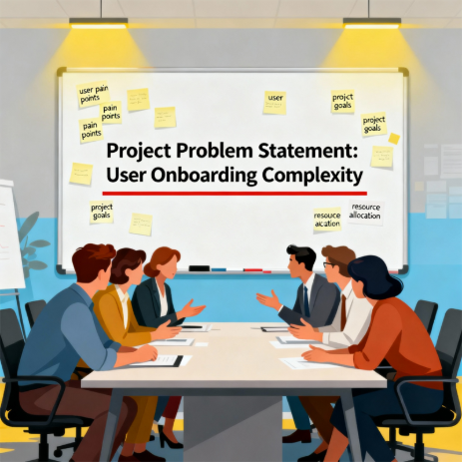

Step-2: Brainstorming, Idea Listing and Grouping

Ideas Generated:

- Create a Service Catalog item for laptop requests.
- Include essential fields: employee name, laptop type, accessories, justification.
- Implement dynamic show/hide fields using UI Policies.
- Provide a reset button for form.
- Track changes via ServiceNow update set.
- Export and deploy as needed.
- Add validation and feedback on submission.

Grouping:

- Form Design: Item, fields, accessories, dynamic behavior
- Automation: UI policy, form reset, notifications
- Governance: Update set tracking, deployment process

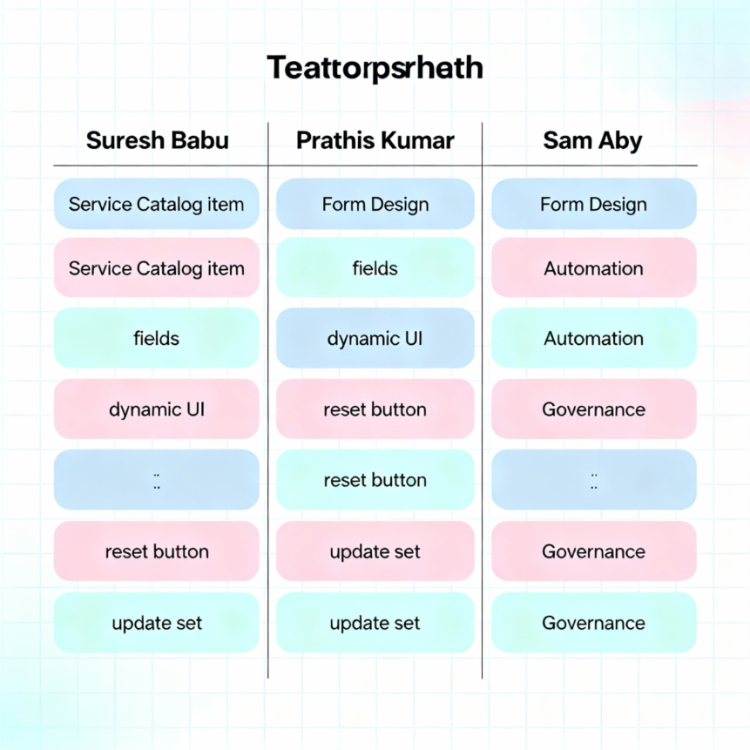

Step-3: Idea Prioritization:

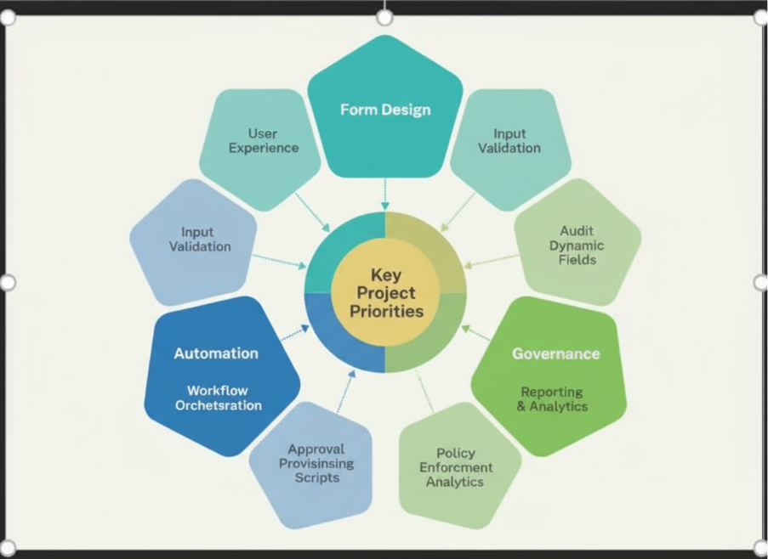

Prioritization:

- Form Design (High Priority): Foundation for user experience
- Automation (Medium Priority): Ensures accuracy and usability
- Governance (Medium Priority): Maintains consistency and audit trail

Conclusion

The ServiceNow Laptop Request Catalog Item project transforms manual processes into user-friendly, automated workflows, supporting IT efficiency and improved service delivery.

